

**A STUDY ON KNOWLEDGE, ATTITUDE AND PRACTICES AMONG DIABETIC PATIENTS AGED 30 YEARSAND ABOVE ATTENDING EMBU PROVINCIAL GENERAL HOSPITAL DIABETIC CLINIC IN EMBU COUNTY**

**KENYA.**

**BY:**

**NAME: EDELQUEEN ITENYA.**

**COLLEGE NO: D/NURS/14014/023**

**FACULTY OF NURSING**

**KENYA MEDICAL TRAINING COLLEGE**

**P.O BOX 923**

**EMBU**

**MARCH 2014 CLASS**

**DECLARATION**

I hereby declare that this research study is my own initiative original work and findings are true representation of the researcher observed in the course of study.

The study information is non-biased and non-discriminative for the partial fulfillment for the award of diploma.

RESEARCHER

NAME: EDELQUEN ITENYA

STUDENT ID: D/NURS/14014/023

SIGNATURE………………………Date…………………….

INTERNAL SUPERVISORS

NAME: MRS. G. NJAGI

DEPARTMENT: NURSING

SIGNATURE………………….Date…………………………..

**DEDICATION**

My special thanks go to the almighty God for giving me good health to carry out this research. My dedication goes to Mr. and Mrs. Daniel Itenya for their moral and financial support. I also thank my teacher Mrs. Njagi for guiding me through writing this report. To my friends and classmates for their moral support, may the lord bless you all.

**TABLE OF CONTENTS**

Declaration………………………………………………………………………………………………………………….…ii

Dedication…………………………………………………………………………………………………………………..…iii

Table of contents…………………………………………………………………………………………………………...iv

Acknowledgement………………………………………………………………………………………………………..vii

Definition of terms………………………………………………………………………………………………………..viii

List of abbreviation ……………………………………………………………………………………………………….vi

Abstract………………………………………………………………………………………………………………………..vii

Research topic……………………………………………………………………………………………………………...viii

**CHAPTER ONE**

Background of the study topic…………………………………………………………………………………….…1

Statement of the problem…………………………………………………………………………………………..…2

**CHAPTER TWO**

Literature review…………………………………………………………………………………………………………..4.

**CHAPTER THREE**

Study methodology……………………………………………………………………………………………………….8.

Study area………………………………………………………………………………………………………………..…..8

Background information……………………………………………………………………………………………....8

Study design……………………………………………………………………………………………………………….…8

Inclusive and exclusive criteria …………………………………………………………………………………....9

Sample size determination………………………………………………………………………………………..…8

Data collection procedure…………………………………………………………………………………………...9.

**CHAPTER FOUR**

Study findings…………………………………………………………………………………………………………….….10

**CHAPTER FIVE**

Discussion …………………………………………………………………………………………………………………..…14

Conclusion ………………………………………………………………………………………………………………….....15

Recommendation…………………………………………………………………………………………………………..15

References…………………………………………………………………………………………………………………….15

**LIST OF FIGURES**

Figure 1.1 knowledge on diabetes………………………………………………………………………………….…11

Figure 1.2 knowledge on types of diabetes…………………………………………………………………......11

Figure 1.3 sources of information on diabetes………………………………………………………………...12

Figure 1.4 knowledge on prevention of diabetes……………………………………………………………..13

**LIST OF ABBREVIATIONS**

DM- Diabetes Mellitus

WHO-World Health Organization

IDF-International Diabetes Federation

GDM-Gestational Diabetes Mellitus

ADA-American Diabetes Association

HHNS-Hyperglycemia Hyperosmolar Non-ketotic Syndrome

ESRD-End Stage Renal Disease

EPGH-Embu Provincial General Hospital

**ABSTRACT**

The research was based on knowledge, attitude and practices among diabetic patients aged 30 years and above attending EPGH. Descriptive study design was used where questionnaires were used as a tool for data collection. The study’s broad objective was to determine knowledge attitude and practices of diabetic patients aged 30 years and above attending EPGH. A study population of 400 respondents was used where a sample size of 10% of the targeted population were interviewed. Systematic sampling was applied. Most clients i.e. 90% had knowledge on diabetes while 10% had no information. Findings showed that majority of the clients lacked knowledge on importance of balanced diet and exercise. The study recommends that health workers should educate the clients on the importance of a well-balanced diet and being actively involved in all forms of exercise.

**RESEARCH TOPIC**

A STUDY ON KWNOLEDGE, ATTITUDE AND PRACTICES AMONG DIABETICS PATIENTS AGED 30 YEARS AND A BOVE ATTENDING EPGH.

Broad objectives

To determine knowledge,attitude and practice of diabetic patient s aged 30 years and aboveattending Embu provincial hospital.

Specific objectives

1. To assess knowledge on diabetes among clients
2. To find out the practices of the diabetic clients
3. To find out the prevention measures of diabetes

RESEARCH QUESTIONS

What knowledge do the diabetic patients have?

What are the practices of diabetic patients?

What are the preventive and control measures of diabetes?

**CHAPTER ONE**

**INTRODUCTION**

**BACKGROUND INFORMATION**

Diabetes is a chronic metabolic disorder characterized by increased level of blood sugars resulting lack of insulin in the body and failures of the body cells top respond to circulating insulin. It is one of the common non-communicable diseases that affect all ages especially the elderly and cuts across all social strata and races.

There has been increasing prevalence of diabetes in U.S.A and worldwide. It is estimated that more than 2-3.6 million people in USA alone have diabetes mellitus and that by 2030,366 million will be diabetic (who 2010).

This is projected rise of diabetic patients from 171 million in 2000 to over 366 million 2030. The diabetic epidemic will continue to rise as there is growing prevalence obesity in children which predisposes one to diabetes (facets Hense 2008)

The increase in people with diabetes mellitus are mainly driven by anticipated increase in world population and urbanization especially in type 2 diabetes mellitus.

**STATEMENT OF THE PROBLEM**

Diabetes is one the most common non-communicable diseases of the 21st century. As of 2016 the global burden if diabetes mellitus in the world was 422 millio0n people up from an estimated 382 million people in 2013 and from 108 million in 1980. Accounting for the shifting age structure of the global population, the prevalence of diabetes is 8.5% among adults, nearly double the rate of 4.7% in 1980.

The international diabetes federation estimates that the figure will rise to 552 million people by 2030 or 9.9% of adults (IDF Atlas 2012)

The world health organization report estimates that diabetes resulted in 1.5 million deaths in 2012 making it the 8th leading cause of death. However, another 2.2 million deaths worldwide were attributed to high blood glucose and the increased risk of cardiovascular diseases and other associated complications e.g. kidney failure which often lead to premature death

Despite the prevalence of DM in developed countries the majority of disease burden from diabetes mellitus, more than 77% is in developing countries because of the large population (African journal sept 2010)

In Kenya, the prevalence of DM is estimated to be 3.3%, this is based on regional projection. It is likely to be underestimated as over 60% of people diagnosed to have diabetes usually present to health care facility with seemingly with unrelated complains, therefore 213 of people don’t know they have it. (National diabetes control program 2011). In Embu provincial general hospital DM has turned top ten common diseases of both young and adults. As revealed in 2015 the number of female who had DM was 7050 and 584 male cases making a total of 1289(Embu health record 2015) compared to 2014 whereby the annual number of people diagnosed were 489.

In 2016 the total number of diabetic patients who attended clinic was 1922.

**A TABLE SHOWING THE TOTAL NUMBER OF PATIENTS AND DIABETIC PATIENTS WHO ATTENDED CLINIC IN OPD ANNUALLY**

|  |  |  |  |
| --- | --- | --- | --- |
| YEAR | No. of diabetic patients | Total No. of patients | percentage |
| 2014  2015  2016 | 489  1289  1922 | 44460  58593  41830 | 1.1%  2.2%  4.6% |

Out of the 1922 diabetic patients who attended clinic in 2016, a total of400 patients aged 30 years and above attended clinic in the month of September and October (Embu health records 2016). With this rising number if something is not done, most of the people will victims.

**STUDY JUSTIFICATION**

Diabetes often goes undetected or undiagnosed because many of its symptoms are often missed or treated as common ailments. In 2013 the global burden was 382 million and projected to be 552 million by 2030. In Africa, it was estimated that 14 million people are suffering from DM in central and southern Africa on it is expected to rise to 28 million people by 2030 (IDF Africa 2015)

In Kenya 15300 people and projected to be 418000 by 2030. This rise in diabetes is associated with social changes and demographic change (WHO report 2014).

In Embu provincial general hospital, diabetic clinic data shows that in 2015 majority of the people who were admitted in the ward were diabetic. A total of 2080 patients were admitted in ward and out of these 460 patients were diabetic, making up 22% of the total cases. There was an increase of 1.4% in the year 2015 compared to the cases of diabetic patients in the year 2014(Embu health records 2015).

**PURPOSE OF STUDY**

1. It was a learning tool to the researchers and add knowledge about diabetes mellitus
2. It was a reference to the researchers who would wish to conduct a similar research in future
3. The study findings are for learning purposes and meant for fulfillment of the award of diploma in Kenya registered community health nursing.

**CHAPTER TWO**

**LITERATURE REVIEW**

Diabetes mellitus commonly referred to as diabetes is a glucose metabolism disease characterized by chronic hyperglycemia with disturbances of carbohydrate, fat and protein metabolism resulting from defects in insulin secretion, insulin action or both (Wikipedia)

Diabetes is categorized into four broad categories: type 1(insulin dependent), type 2(non-insulin dependent), Gestational diabetes and other specific types. The specific types are a collection of a few dozen causes. Diabetes is a more variable disease than once thought and people may have combinations of forms. The term “Diabetes”, without qualification, usually refers to diabetes mellitus (Wikipedia).

Different types of diabetes have different causes, clinical manifestations and treatment. Classification is however dynamic; First research suggests that there are many differences in each category, second except for people with type 1 diabetes, may move from one category to another e.g. a woman with gestational diabetes after delivery may move to type 2 category.

**KNOWLEDGE**

Until a few years ago a limited number of epidemiologist and health experts mentioned the word diabetes. A new life style imported dietary practices takes root in developing world and Africa today. Diabetes and its complications are considered epidemic compelling African governments to start paying more attention to its impact whereby thousands of Africans run the risk of dying young (World diabetic federation 2010}.

The term DM was first coined by Arctorcappodica in 181-133AD. Later the word mellitus meaning honey, sweetness was discovered in urine and blood by the ancient Greek. In modern time the history of diabetes is established under experimental medicine (Richard et al 2010}.

Scientists have divided DM into three different types: type 1, type 2, and Gestational DM and recently they have added a fourth category, tropical diabetes (International diabetes atlas 2007}.

**Type 1 Diabetes Mellitus**

Previous known as insulin-dependent diabetes mellitus(IDDM), this occurs mainly in children and young adults; the onset is usually sudden and can be life threatening. There is severe deficiency or absence of insulin secretion due to destruction of B-islet cells of pancreas. Treatment with injection of an autoimmune mechanism involving antibodies that destroy the B-islet cells. Genetic predisposition and environmental factors, including viral infections are also implicated. (Ross et al 2012).

In developed countries, almost all patients have immune medicated form of the disease. This is an autoimmune disorder where the body produces antibodies which destroy the insulin producing cells of the pancreas. Type 1 diabetes is the second most chronic disease of childhood after asthma. (Clinicians Desk Reference-Diabetes 2012).

It causes approximately 10% of diabetes mellitus cases in North America and Europe. Most affected people are otherwise healthy and of a healthy weight when onset occurs. “Brittle” the dramatic and recurrent swings in glucose levels, often occurring for no apparent reason in insulin dependent diabetes.

This term however has no biological basis and should not be used.Still, type 1 diabetes can be accompanied by irregular and unpredictable blood sugar levels, frequently with ketosis and sometimes with serious low sugar levels. Other complications include counter regulatory response to low blood sugar level, infection, gastro paresis (which leads to erratic absorption of dietary carbohydrates) and believed to occur in no more frequently than in 1% to 2% of persons with type 1 diabetes. (Wikipedia)

**TYPE 2 DIABETES MELLITUS**

Previously known as non-insulin dependent diabetes mellitus (NIDDM), this is the most common form of diabetes, accounting form of diabetes, accounting for about 90% of cases (Ross et al 2012). Type 2 diabetes mellitus occurs as a result of relative insulin deficiency, where the pancreas does not produce enough insulin, and insulin resistance where the body’s cells do not react normally to insulin.

The exact cause of type 2 diabetes is not understood, but risk factors include obesity, having a close relative with type 2 diabetes, being of south Asian, Africa-Caribbean or Middle Eastern descent and being over 40 years of age (Leslie et al 2012). A number of lifestyle factors are known to be important to the development of type 2 DM, including obesity (defined by body mass index of greater than 30, lack of physical activity, poor diet, stress and urbanization). Excess body fat is associated with 30 % of cases in those of Chinese and Japanese descent, 60-80% in those of European and African descent,

And 100% of Pima Indians and pacific islanders. Even those who are not obese often have a high waist-hip ratio (Wikipedia).

**GESTATIONAL DIABETES MELITUS**

This is defined as carbohydrate intolerance resulting in hyperglycemia of variable severity, with its onset or first recognition during pregnancy (WHO 2013). Gestational Diabetes Mellitus (GDM) resembles type 2 DM. in several respects, involving a combination of relatively inadequate insulin secretion and responsiveness. It occurs in a bout 2-10% of all pregnancies and may improve or disappear after delivery. However, after pregnancy approximately 5-10% women with gestational diabetes are found to have diabetes mellitus, most commonly type 2. Gestational diabetes is fully treatable but requires careful medical supervision throughout the pregnancy (Wikipedia). There is evidence to suggest that women who develop GDM are at risk of developing type 2 DM (Verjee et al 2001). Davey and Hamblin (2001) identity that some women are at high risk of GDM and there may be some benefits in selective screening for GDM in women where the following risk factors are identified.

PRACTICES

People with diabetes can benefit from education about the disease and the treatment, good nutrition to achieve normal body weight, and exercise, with a goal of keeping both short term and long term blood glucose levels within acceptable bounds (Wikipedia). Insulin therapy is necessary especially for type 1 diabetes mellitus who multiple injections each day. Insulin may also be required to treat type 2 diabetes. An insulin pump which is usually worn on the belt may also be used. Insulin is delivered through a small tube (catheter) under the skin (in the abdomen). There are four types of insulin: rapid acting – used for rapid reduction of glucose levels. Short acting insulin which is administered 20-30 minutes before a meal. Intermediate acting is usually taken after food and long acting which used for basal dose. However, administration of insulin depends on body weight, when you eat, how often you exercise and how much insulin your body produces. Oral hypoglycemia drugs are given to people with type 2 diabetes. If they eat in a healthy manner and exercise and blood sugar levels remain high. They work in different ways to include, effectiveness of body’s natural insulin, reduce blood sugars production, increase insulin production and exhibit sugars absorption. They can however be combined with insulin.

PREVENTIVE MEASURES

In the view of rising in prevalence rate of DM in Kenya, it was recognized that due to morbidity, premature death and increasing health cost prevention is of paramount importance. Also public and professional awareness of the risk factors for and symptoms diabetes are an important step towards its control and prevention (Leslie et al 2012}.

The Diabetes Prevention Program (DPP} results indicate that millions of high-risk people can delay or avoid developing type 2 diabetes by losing weight through regular physical activity and a diet low in fat and calories. Weight loss and physical activity lower the risks of diabetes by improving the body’s ability to use insulin and process glucose.

The DPP also suggest that metformin can help delay the onset of diabetes participants in the lifestyle intervention group-those receiving intensive individual counselling and motivational support on effective diet,exercise and behavior modification.

**CHAPTER THREE**

**STUDY METHODOLOGY**

**BACKGROUND INFORMAION ON THE STUDY AREA**

Embu Provincial General Hospital is in Embu county, Manyatta constituency. It has a population of approximately 154,632 people. EPGH is located along Embu-Meru road. It is an agricultural area with major cash crop being tea and coffee, staple food like maize, beans cow peas and other cereals are also grown.

**STUDY DESIGN**

A descriptive design type of study carried out in Embu provincial general hospital, diabetic to determine the knowledge attitude and practices among diabetic patients aged 30 years and above.

**TARGET POPULATION**

According to Abel and Muga (2003) population is a complete set of individuals, cases or objects with the same observable characteristics. The researcher main population was both male and female aged 30 years and above suffering from diabetes mellitus attending diabetes clinic.

**SAMPLE SIZE AND TARGET POPULATION**

Target population was 400 people and sample size required was 10% of the target population and according to Gay’s formulae

N-target population

10% ×400(n) =sample size

10/100×400=40

Therefore,sample size=40 respondents.

**DATA COLLECTION**

The technique used in data collection is use of questionnaire and convenient sampling method, where the researcher interviewed the respondents as they become available by use of filling questionnaire.

**RESEARCH TOOLS**

Researcher used pen, pencils, stationary, calculator, computer software and questionnaire.

**INCLUSIVE CRITERIA**

All diabetic patients aged 30years and above attending clinic in Embu provincial general hospital.

**EXCLUSIVE CRITERIA**

Non-diabetic patients

Diabetic patients in the ward

Those of unsound mind

Diabetic patients aged 29 years and below.

**ETHICAL CONSIDERATIONS**

Throughout the research process, confidentiality was maintained hence encouraging full participation of the clients. There was no writing of names and the accessible population had the freedom to make voluntary decisions to participate. If subject wanted to withdraw at my stage of interview, they were at liberty. There was no discrimination in sample selection. Data collection was used for the intended purpose and not any other.

**VARIABLES**

**Independent variables**

1. Knowledge
2. Attitude
3. Practices

**Dependent variables**

1. Diabetes mellitus.

**CHAPTER FOUR**

**STUDY FINDINGS**

**TABLE 1.1 SHOWING RESPONDENTS AGE**

|  |  |  |
| --- | --- | --- |
| Age group | Frequency | Percentage (%) |
| Below 15 years | 2 | 5 |
| 16-25 years | 6 | 15 |
| 26-35 years | 8 | 20 |
| 36 and above | 24 | 60 |
| Total | 40 | 100 |

Majority of the respondents 60% were aged 36 years and above

**TABLE 1.2 SHOWING RESPONDETS LEVEL OF EDUCATION**

|  |  |  |
| --- | --- | --- |
| Level | frequency | Percentage (%) |
| Primary | 10 | 25 |
| Secondary | 18 | 45 |
| College | 10 | 25 |
| Never went to school | 12 | 5 |
| Total | 40 | 100 |

Majority of the respondents had reached secondary level of education, that 45%

**TABLE 1.3 SHOWING RESPONDENTS ON OCCUPATION ACTIVITY**

|  |  |  |
| --- | --- | --- |
| Occupation | Frequency | Percentage (%) |
| Sedentary | 30 | 75 |
| Mixed | 6 | 15 |
| Active | 4 | 10 |
| Total | 40 | 100 |

Majority of the respondents had sedentary type of occupation that is 75%

**FIGURE 1.1 SHOWING KNOWLEDGE ON DIABETES**

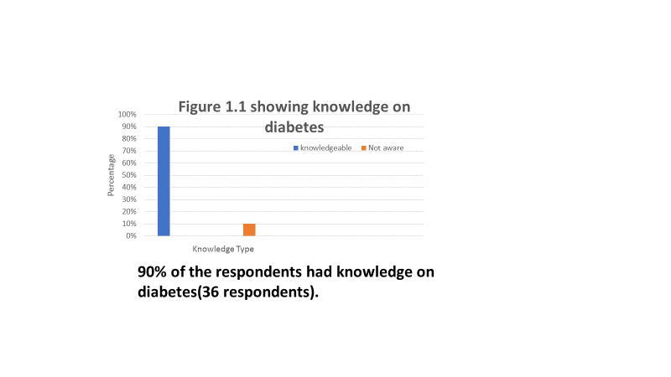

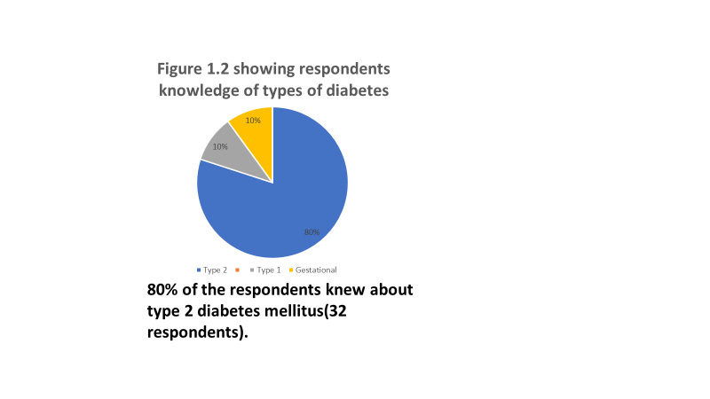

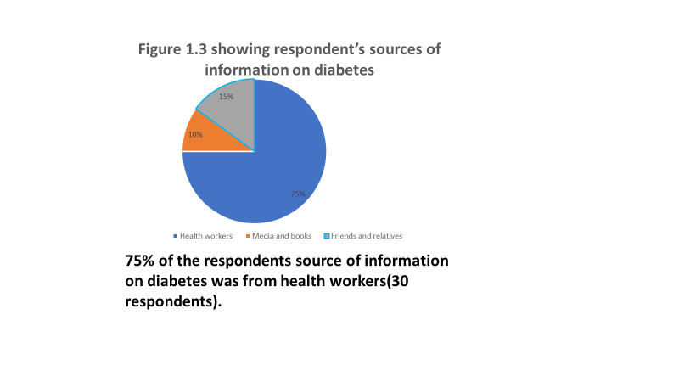

TABLE 1. 4 SHOWING RESPONDENT’S MANGEMENT OF DIABETES

|  |  |  |
| --- | --- | --- |
| Type of medication | Frequency | Percentage (%) |
| Injection | 14 | 35 |
| Oral drugs | 14 | 35 |
| Diet and exercise | 12 | 30 |
| Total | 40 | 100 |

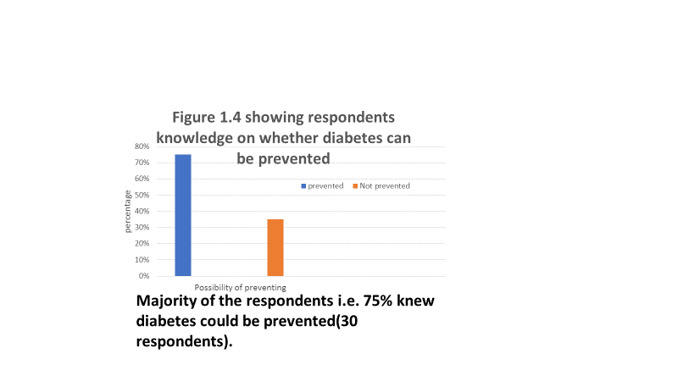

**CHAPTER FIVE**

**DISCUSSION AND INTERPRETATION**

90% of the respondents had general knowledge on diabetes mellitus while 10% had no information. On types of diabetes 80% knew about type 2 diabetes mellitus, 105 type 1 and another 10% knew gestational diabetes mellitus. Majority of the respondentsi.e. 75% got information about diabetes mellitus from the health workers, 15% from friends and relatives and 10% from media and books.

Majority of the respondents 60% were aged 36 years and above, 20% between 26-35years, 15% between 16 and 25 years and 5% below 15years. 45% had gone up to secondary level of education, 25% up to college level, another 25% up to primary level of education and 5% never went to school. Majority of the respondents 75% had sedentary type of occupation, 10% had active and 15% had mixed type of occupation.

35% the respondents managed diabetes through drug therapy(injection) and another 35% through oral drugs. 30% managed through diet and exercise. 75% of the respondents knew diabetes could be prevented while 25% did not know. Majority of the respondents 75% said diabetes could be prevented through proper diet, 15% through exercise and 10% through regular blood sugar monitoring.

**CONCLUSION**

The study show low level of diabetes awareness nut positive attitude towards the importance of DM case and satisfactory diabetes practices among the clients. Programs to increase patient’s awareness about DM are essential for all diabetics attending clinic in EPGH in order to improve their understanding,compliance and management and thereby their ability to cope with the disease.

**RECOMMENDATION**

1. MOH to establish a program whereby there will be an open day for middle aged elderly blood glucose monitoring and checkup to control DM.
2. Health workers to teach the public on importance of balanced diet and what it is composed of to reduce cases of diabetes.
3. Encourage people to involve themselves actively in exercises pf all forms e.g. walking, jogging etc.

**REFERENCES**

1. Leslie D.R et al (2012), Clinicians Desk Reference 2nd edition, New York, Lipicott Williams International.
2. Brunner et al (2012). Text book of medical-surgical Nursing, 13th edition, china, Wolters Kluwer publishers Ltd
3. Ross et al (2012) Anatomy and physiology in health and illness, 12th edition, china, Elsevier publisher Ltd.
4. Jayne E. et al (2014) Myles textbook for midwives, 3rd edition, South Africa, Elsevier publishers Ltd.
5. Richard s. et al (2010) Manual of intensive care medicine, 5thedition, Philadelphia, Walters Kluwer health /LippincottWilliams and Wilkins publishers Ltd.
6. EPGH health records.

QUESTIONNAIRE

Put a tick in the spaces provided against each question

1. Gender
2. Male
3. Female
4. What is your age?
5. Education
6. Primary
7. Secondary
8. Higher education
9. None
10. Occupation type
11. Sedentary
12. Active
13. Mixed
14. None

KNOWLEDGE

1. When were you diagnosed with diabetes mellitus?
2. Less than 1 month ago
3. Between 1 month and 1 year
4. More than a year ago
5. Do you know the type of diabetes you are suffering from?
6. Yes
7. No
8. If yes, what type?
9. Type 1
10. Type 2
11. Type 3
12. Where did you get the information about diabetes from?
13. Health workers
14. Friends and relatives
15. Media and books
16. What diabetic medications are you on?
17. Injection
18. Oral
19. Diet and exercise
20. How often do you take your medication?
21. Once per day
22. Twice a day
23. Thrice aday

ATTITUDE

1. Is diabetes mellitus curable?
2. Yes
3. No
4. Is your condition improving?
5. Yes
6. No

PRACTICES

1. Do you use insulin?
2. Yes
3. No
4. Do you use other antibiotics?
5. Yes
6. No
7. If yes which one………………………………
8. How many meals do you take per day?
9. One
10. Two
11. Three
12. Other
13. How often do you exercise?
14. Daily
15. Twice a week
16. None